|  |  |
| --- | --- |
| Issue Date: | Revised and Re-Issued on November 11, 2022 |
| Building Code Sections: | 2018 IBC Sections 308, 310, 903.3.1.3, 906, 907, 1006, 1008, 1010, 1012, 1013, 1028.5, 1030.2, 1107.6, and the ADASAD Technical Requirements |
| Developed by: | Development Services Department/Building Safety Division |
| Approved by: | Djordje Pavlovic, P.E. (Building Safety Official) |
| References: | Arizona Department of Health Services Revised Statues 36-401. |

**PURPOSE:**

The purpose of this Technical Guideline is to clarify the requirements of Group (Care) Homes 1-5 Occupants and 6-10 Occupants. The 1-5 Occupants Group home shall follow all of the applicable requirements of the adopted 2018 IRC as well must have an approved AFES (automatic fire extinguishing system) installed. The 6-10 Occupants Group Home shall follow the following requirements:

**RESIDENTIAL GROUP CARE FACILITY R-4, 6-10 OCCUPANTS**

**Definition: R-4 Residential occupancies shall include buildings arranged for occupancy as residential care/assisted living facilities including at least 6 but not more than 10 occupants, excluding staff.**

**Arizona Department of Health Services Revised Statues. 36-401. Definitions: Adult Foster Care. Article 9 “Assisted living home” means an assisted living facility that provides resident rooms to ten or fewer residents.**

**Maricopa County has jurisdiction to Approve for Construction any Glendale projects that involve remodeling and/or adding SF to an existing structure served by a septic sewer system. The Owner/General Contractor will be required to get Maricopa County’s review and approval of drawings and details to determine if the existing septic system is adequate to accommodate the new construction. Approval documentation is required before the City of Glendale may issue permits.**

**308.2 Institutional Group I-1.** Institutional Group I-1 occupancy shall include buildings, structures, or portions thereof for more than 16 persons, excluding staff, who reside on a 24- hour basis in a supervised environment and receive custodial care. Buildings of Group I-1 shall be classified as one of the occupancy conditions specified in Section 308.2.1 or 308.2.2. This group shall include, but not be limited to, the following:

Alcohol and drug centers

Assisted living facilities

Congregate care facilities

**Group homes**

Halfway houses

Residential board and care facilities

Social rehabilitation facilities

**308.2.1 Condition 1.** This occupancy condition shall include buildings in which all persons receiving custodial care who, without any assistance, are capable of responding to an emergency situation to complete building evacuation.

**308.2.2 Condition 2.** This occupancy condition shall include buildings in which there are any persons receiving custodial care who require limited verbal or physical assistance while responding to an emergency situation to complete building evacuation.

**308.2.3 Six to 16 persons receiving custodial care.** A facility housing not fewer than six and not more than 16 persons receiving custodial care shall be classified as Group R-4.

**308.2.4 Five or fewer persons receiving custodial care.** A facility with five or fewer persons receiving custodial care shall be classified as Group R-3 or shall comply with the International Residential Code provided an automatic sprinkler system is installed in accordance with Section 903.3.1.3 or Section P2904 of the International Residential Code.

**310.5 Residential Group R-4.** Residential Group R-4 occupancy shall include buildings, structures, or portions thereof for more than five but not more than 16 persons, excluding staff, who reside on a 24-hour basis in a supervised residential environment and receive custodial care. Buildings of Group R-4 shall be classified as one of the occupancy conditions specified in Section 310.5.1 or 310.5.2. This group shall include, but not be limited to, the following:

Alcohol and drug centers

Assisted living facilities

Congregate care facilities

Group homes

Halfway houses

Residential board and care facilities

Social rehabilitation facilities

Group R-4 occupancies shall meet the requirements for construction as defined for Group R-3, except as otherwise provided for in this code.

**310.5.1 Condition 1.** This occupancy condition shall include buildings in which all persons receiving custodial care, without any assistance, are capable of responding to an emergency situation to complete building evacuation.

**310.5.2 Condition 2**. This occupancy condition shall include buildings in which there are any persons receiving custodial care who require limited verbal or physical assistance while responding to an emergency situation to complete building evacuation

**IBC 903.2.8.1** Automatic sprinkler systems. Group R-3 or R-4 congregate residences. An automatic sprinkler system installed in accordance with **Section IBC 903.3.1.3(NFPA 13D Sprinkler system)** shall be permitted in Group R-3 or R-4 congregate residences with 16 or fewer residents.

**IBC 906.1** Portable fire extinguishers Where required. **IBC 906.9.1 through 906.9.3** within 75’ per **Table 906.3(1)** mounted to not protrude more than 4” per ADA 307.

**IBC 906.1 Table 906.3 (1)** A minimum of 1 per 3,000 sq. ft., maximum 75 feet travel distance, 2-A 10-B fire extinguisher(s)at a location specified by the Fire Inspector.

**IBC 907.2.10 Group R-4.** Fire alarm systems and smoke alarms shall be installed in Group R-4 occupancies as required in Sections 907.2.10.1 through 907.2.10.3.

**IBC 907.2.10.2 Group R-4.** Single-or multiple-station smoke alarms shall be installed and maintained in Group R-4 regardless ofoccupant load at all of the following locations:

1. On the ceiling or wall outside of each separate sleeping area in the immediate vicinity of bedrooms.

2. In each room used for sleeping purposes.

3. On each story within a dwelling unit.

**IBC 907.2.10.5 Interconnection.** Where more than one smoke alarm is required to be installed within an individual dwelling unit or sleeping unit in Group R-4 occupancy, the smoke alarms shall be interconnected in such a manner that the activation of one alarm will activate all of the alarms in the individual unit. Physical interconnection of smoke alarms shall not be required where listed wireless alarms are installed and all alarms sound upon activation of one alarm. The alarm shall be clearly audible in all bedrooms over background noise levels with all intervening doors closed.

**IBC 907.2.10.6 Power Source**. In new construction. Required smoke alarms shall receive their primary power from the building wiring where such wiring is served from a commercial source and shall be equipped with a battery backup. Smoke alarms with integral strobes that are not equipped with battery backup shall be connected to an emergency electrical system. Smoke alarms shall emit a signal when the batteries are low. Wiring shall be permanent and without a disconnecting switch other than as required for overcurrent protection.

**IBC Table 1006.2.1 Common path of egress travel. Shall not exceed 125’.**

**IBC 1006.2.2.6 Groups R-3 and R-4.** Where Group R-4 occupancies are permitted by Section 903.2.8 to be protected by an automatic sprinkler system installed in accordance with Section 903.3.1.3, the exit access travel distance for Group R-4 shall be not more than **75 feet** (22 860 mm).

**PROVIDE per Technical Guideline 4-30-2019 - IBC 1007.1.1 Two exits or exit access doorways.** Where two exits or exits access doorways are required from any portion of the exit access, the exit doors or exit access doorways shall be placed a distance apart equal to not less than one-half of the length of the maximum overall diagonal dimension of the building or area to be served measured in a straight line between exit doors or exit access doorways. Exception 2. Where a building is equipped throughout with an automatic sprinkler system in accordance with Section 903.3.1.1 or 903.3.1.2, the separation distance shall be not less than one-third of the length of the maximum overall diagonal dimension of the area served.

**IBC 1008.1 Mean of Egress Illumination. Illumination required.** The means of egress (hallways, doors, entry/exit), including the exit discharge, shall be illuminated at all times the building space served by the means of egress is occupied.

1008.2.1 Illumination Level Under Normal Power

The [*means of egress*](https://up.codes/viewer/illinois/ibc-2018/chapter/2/definitions#means_of_egress) illumination level shall be not less than 1 footcandle (11 lux) at the walking surface.

**IBC 1008.3 Emergency power for illumination.** In the event of power supply failure, an emergency electrical system shall automatically illuminate all of the areas: See IBC1008.3(1-5) The emergency power system shall provide power for a duration of not less than 90-minutes and shall consist of storage batteries, unit equipment or an on-site generator. The installation of the emergency power system shall be in accordance with Section 2702.

**IBC 1008.3 Emergency power for illumination.** The power supply for means of egress illumination shall normally be provided by the premises’ electrical supply.

**IBC 1008.3.1 General**. In the event of power supply failure in rooms and spaces that require two or more means of egress, an emergency electrical system shall automatically illuminate all of the following areas: 1. Aisles. 2. Corridors. 3. Exit access stairways and ramps.

**IBC 1008.3.2** Buildings. In the event of power supply failure in buildings that require two or more means of egress, an emergency electrical system shall automatically illuminate all of the following areas: 1. Interior exit access stairways and ramps. 2. Interior and exterior exit stairways and ramps. 3. Exit passageways. 4. Vestibules and areas on the level of discharge used for exit discharge in accordance with Section 1028.1. 5. Exterior landings as required by Section 1010.1.6 for exit doorways that lead directly to the exit discharge.

***(Note: Emergency lighting is required at the landings outside of exit doors, but not along the exit discharge path.) per Technical Guideline 4-30-2019***

**IBC 1008.3.4 Duration**. The emergency power system shall provide power for a duration of not less than 90 minutes and shall consist of storage batteries, unit equipment or an on-site generator. The installation of the emergency power system shall be in accordance with Section 2702.

**IBC 1008.3.5 Illumination level under emergency power.** Emergency lighting facilities shall be arranged to provide initial illumination that is at least an average of 1 foot-candle (11 lux) and a minimum at any point of 0.1 foot-candle (1 lux) measured along a path of egress at the floor level. Illumination levels shall be permitted to decline to 0.6 foot-candle (6 lux) average and a minimum at any point of 0,06 foot-candle (0.6 lux) at the end of the emergency lighting time duration. A maximum-to-minimum illumination uniformity ratio of 40 to 1 shall not be exceeded.

**IBC 1010.1.1 Size of doors.** The required capacity of each door opening shall be sufficient for the occupant load thereof and shall provide a minimum clear opening width of 32 inches. (36” wide door.) The height of the door openings shall not be less than 80 inches.

**IBC 1010.1.2 Door swing.** Egress doors shall be of the pivoted or side-hinged swinging type.

**Exception: 7. Power-operated doors in accordance with Section 1010.1.4.2.**

**IBC 1010.1.4.3** Special purpose horizontal sliding, accordion or folding doors. Exception: 2. The doors shall be openable by a simple method from both sides without special knowledge or effort.

**Security Gates** **(ADASAD 404.2.6 Doors in Series and Gates in Series)** The distance between two hinged or pivoted doors in series and gates in series shall be 48” minimum plus the width of the doors or gates swinging into the space.

**IBC 1010.1.6 Landings at doors.** Landings shall have a width not less than the width of the stairway or the door, whichever is greater. Landings shall have a length measured in the direction of travel of not less than 44 inches.

**IBC 1010.1.7 Thresholds. (ADASAD 404.2.5 Thresholds)** Thresholds at doorways shall not exceed ¾” in height above the finished floor or landing for sliding doors serving dwelling units or ½” above the finished floor or landing for other doors. Raised thresholds and floor level changes greater than 1/4” at doorways shall be beveled with a slope not greater than one-unit vertical in two units horizontal (50 percent slope).

**(ADASAD 404.2.5 Thresholds)** Thresholds shall be ½” high maximum. Raised thresholds and changes in level at doorways shall comply with 302 and 303. Exception: Existing or altered thresholds ¾” high maximum that have a beveled edge on each side with a slope not steeper than 1:2 shall not be required to comply with 404.2.5

**ADA 404.2.4 Maneuvering Clearances.** Table 404.2.4.1 maneuvering clearances a manual swing doors and gates.

**IBC 1010.1.9 Door Operations.** Except as specifically permitted by this section egress doors shall be readily openable from the egress side without the use of a key or special knowledge or effort.

**IBC 1010.1.9.1 Hardware.** Door handles, pulls, latches, locks, and other operating devices on doors required to be accessible by Chapter 11 shall not require tight grasping, tight pinching or twisting of the wrist to operate.

**(ADASAD 309 Operable Parts. 309.4 Operation.)** Operable parts shall be operable with one hand and shall not require tight grasping, pinching, or twisting of the wrist. The force required to activate operable parts shall be 5 pounds maximum.

**1010.2 Gates.** Gates serving the means of egress system shall comply with the requirements of this section. Gates used as a component in a means of egress shall conform to the applicable requirements for doors.

*Note: Exterior gates in the path of exit egress discharge shall be 36” wide and gate hardware shall be ADA compliant. Per Technical Guideline 4-30-2019.*

**IBC 1010.1.9.6** Unlatching. The unlatching of any door or leaf shall not require more than one operation.

**IBC 1010.1.9.6.1 Closet doors. Closet doors that latch in the closed position shall be openable from inside the closet.**

**IBC 1012 Ramps. 1012.1 Scope.** The provisions of this section shall apply to ramps used as a component of a means of egress. (Ramps shall be installed at all required exits.)

**IBC 1012.6.2 Ramp Width.** Landings at ramps shall be at least as wide as the widest ramp run adjoining to the landing.

**IBC 1012.6.3 Ramp Length.** The landing length shall be 60 inches minimum.

**IBC 1012.6.4 Change in direction.** Where changes in direction of travel occur at landings provided between ramp runs, the landing shall be 60 inches by 60 inches minimum.

**IBC 1013.1 Exit signs.** Exits and exit access doors shall be marked by an approved exit sign readily visible from any direction of egress level.

**IBC1013.3 Illumination**. Exit signs shall be internally or externally illuminated. Exception: Tactile signs required by Section 1013.4 need not be provided with illumination.

**IBC 1013.4 ADA 216 & 703.2** Raised character & Braille exit signs.

**IBC Table 1020.2 Minimum corridor width.** 36 inches clear width at hallways.

**IBC 1028.5 Access to public way.** The exit discharge shall provide a direct & unobstructed access to a public way. Exception: Where access to a public way cannot be provided, a safe dispersal area shall be provided where all the following are met. (See IBC 1028.5 Exception: 1 through 4) (Not less than 50’ away from the building.)

**IBC 1030.2 Emergency escape and rescue.** Minimum size. Emergency escape and rescue openings shall have a minimum net clear opening of 5.7 square feet. Exception: The minimum net clear opening for grade-floor emergency escape and rescue openings shall be 5 square feet.

**IBC 1030.2.1 Minimum dimensions.** The minimum net clear opening height dimension shall be 24”. The minimum net clear opening width dimension shall be 20”. The net clear opening dimensions shall be the result of normal operation of the opening. (and a finished sill height of not more than 44 inches above the floor.)

**IBC 1107.6.1.1 Accessible units.** Accessible dwelling units and sleeping units shall be provided in accordance with Table 1107.6.1. All dwelling units and sleeping units on a site shall be considered to determine the total number of Accessible units. Accessible units shall be dispersed among the various classes of units.

**IBC 1107.6.4 Group R-4. Accessible units and Type B units shall be provided in Group R-4 occupancies in accordance with Sections 1107.6.4.1 and 1107.6.4.2. Bedrooms in Group R-4 facilities shall be counted as sleeping units for the purpose of determining the number of units.**

**IBC 1107.6.4.1 Accessible units. In Group R-4, Condition 1, at least one of the sleeping units shall be an Accessible unit. In Group R-4, Condition 2, at least two of the sleeping units shall be an Accessible unit.**

**IBC 1107.6.4.2 Type B units. In structures with four or more sleeping units intended to be occupied as a residence, every sleeping unit intended to be occupied as a residence shall be a Type B unit. Exception: The number of Type B units is permitted to be reduced in accordance with Section 1107.7.**

**IBC 1107.6.4 Group R-4. Accessible units and Type B units shall be provided in Group R-4 occupancies in accordance with Sections 1107.6.4.1 and 1107.6.4.2**

**IBC1107.6.4.1 Accessible units. At least one of the dwelling units or sleeping units shall be an Accessible unit. (Minimum 1-bedroom door is to have at least 36-inch clear width.)**

**IRC R703.9** EIFS 6” above grade. **IRC 703.12.1** Adhered masonry veneer & **R703.7.2.1** Exterior Plaster (Stucco) Stucco system with weep screed. Minimum ½” above slab at required exits in R-4. - 2” above paved surface and 4” above earth.

**R703.7.2.1** **Weep screeds.** A minimum 0.019-inch (No. 26 galvanized sheet gage), corrosion-resistant weep screed or plastic weep screed, with a minimum vertical attachment flange of 3 1/2 inches, shall be provided at or below the foundation plate line on exterior stud walls in accordance with ASTM C926. The weep screed shall be placed not less than 4 inches above the earth or 2 inches above paved areas and shall be of a type that will allow trapped water to drain to the exterior of the building. The weather-resistant barrier shall lap the attachment flange. The exterior lath shall cover and terminate on the attachment flange of the weep screed.

**ADASAD**

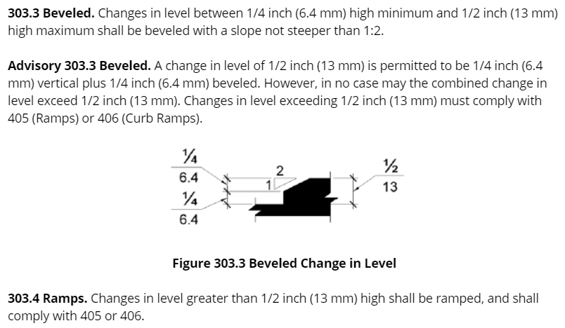

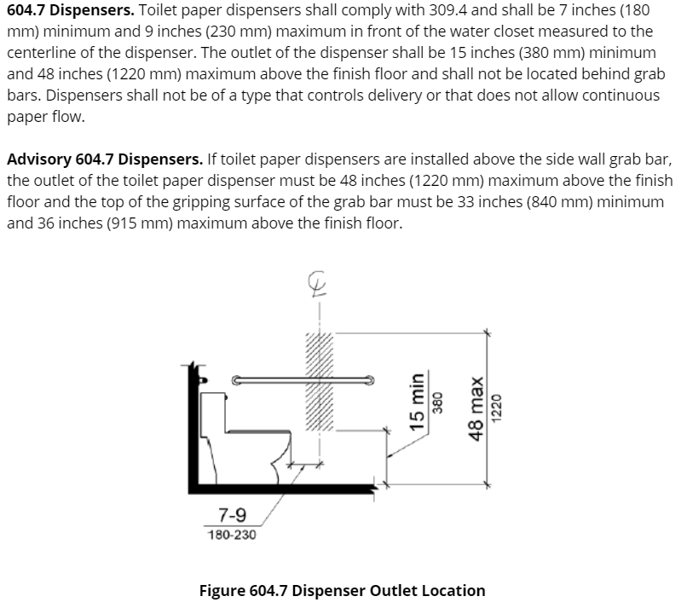

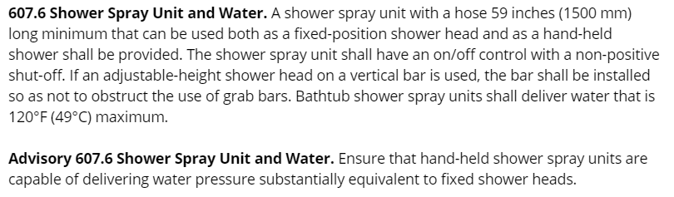

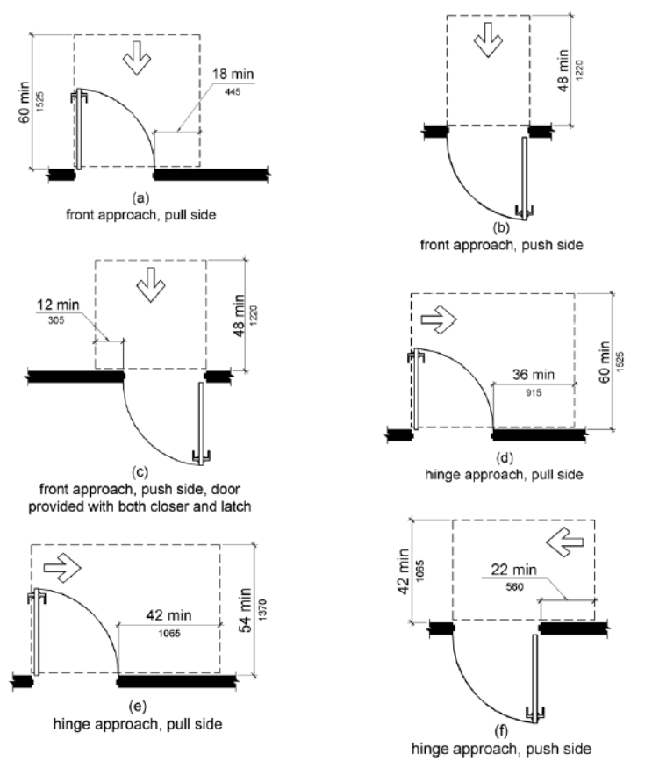

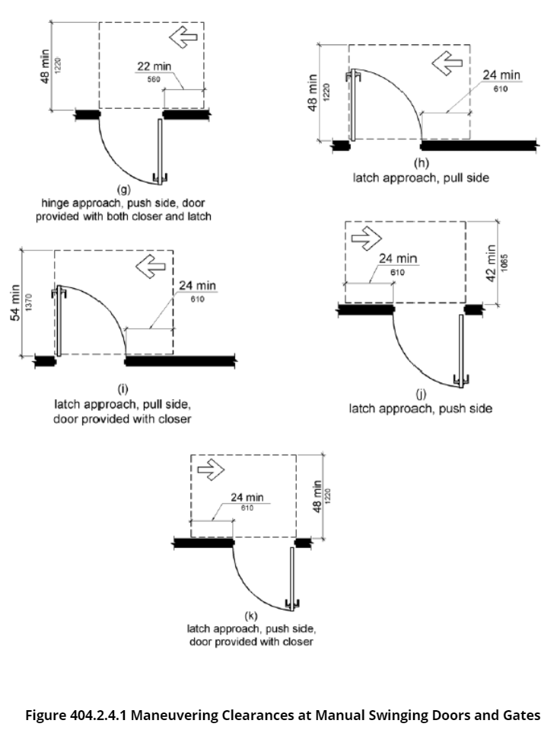

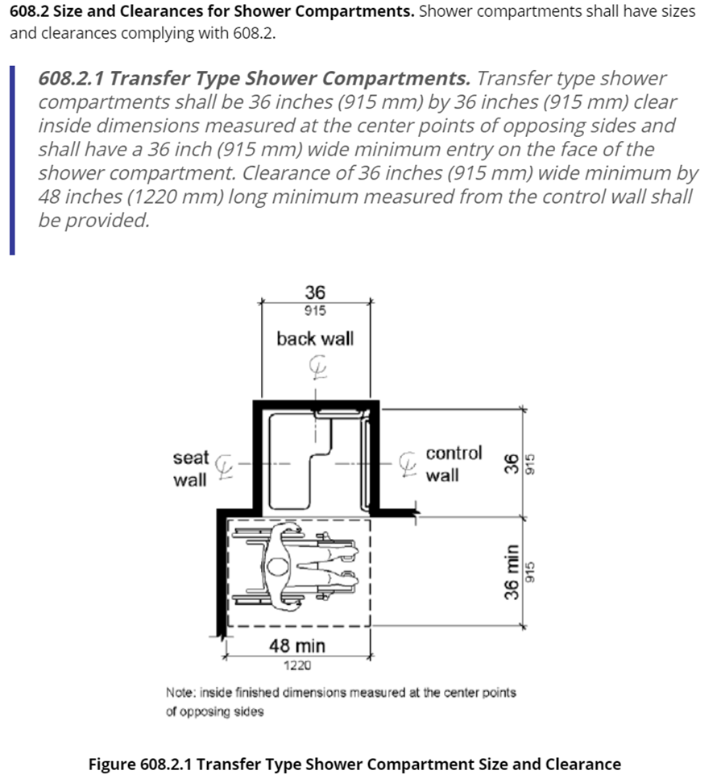

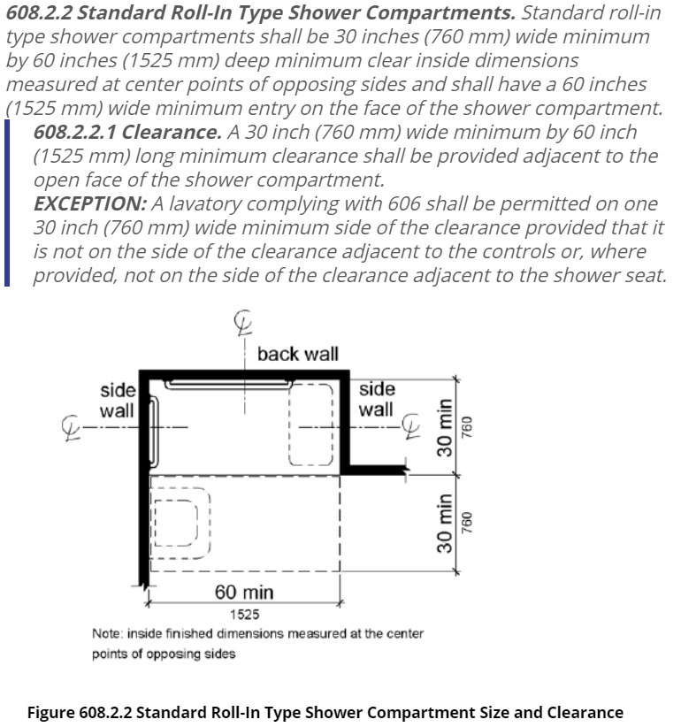

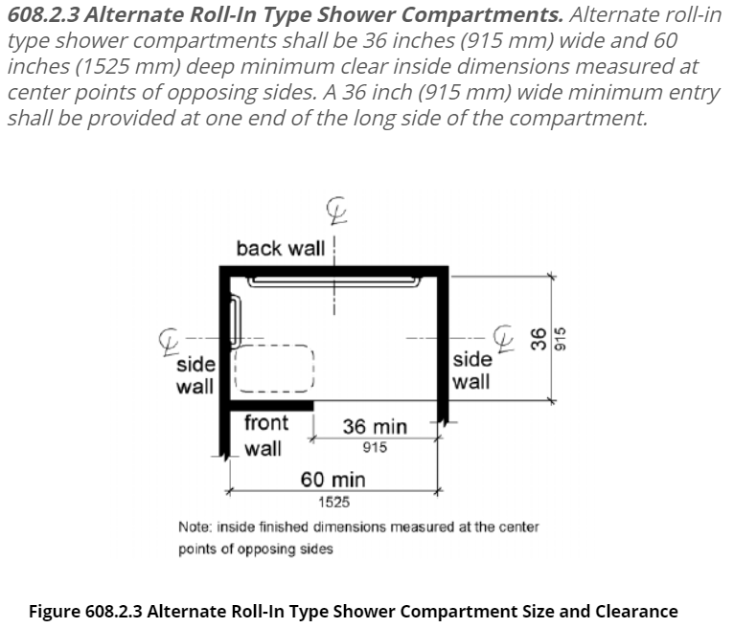

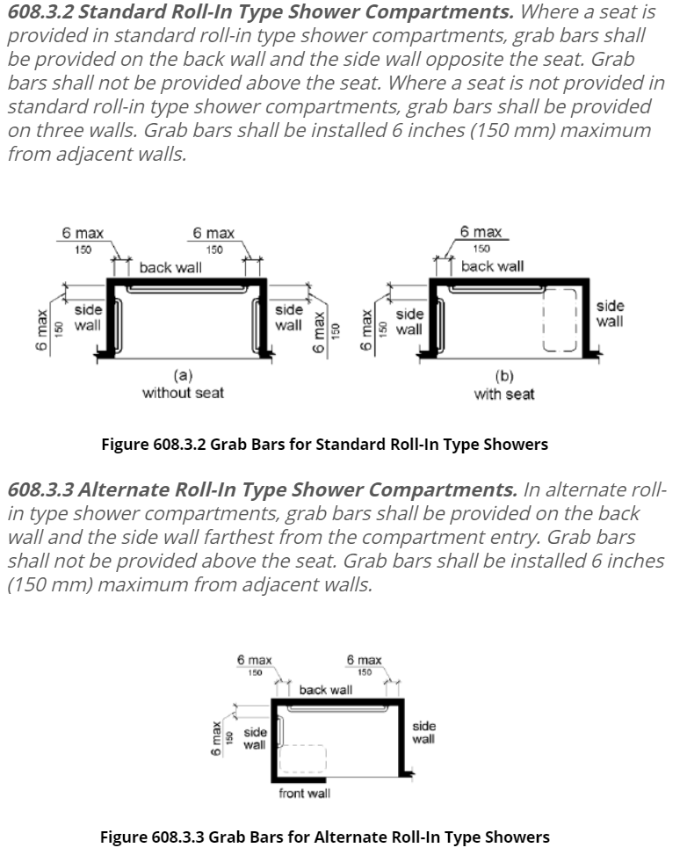

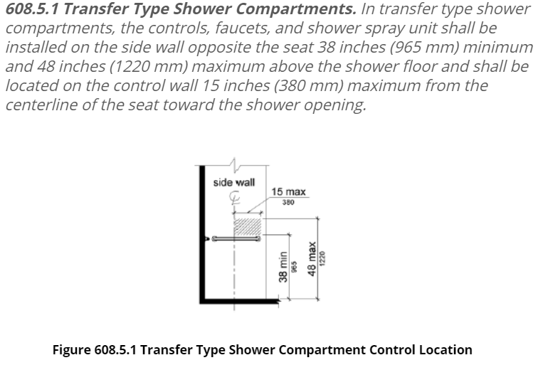

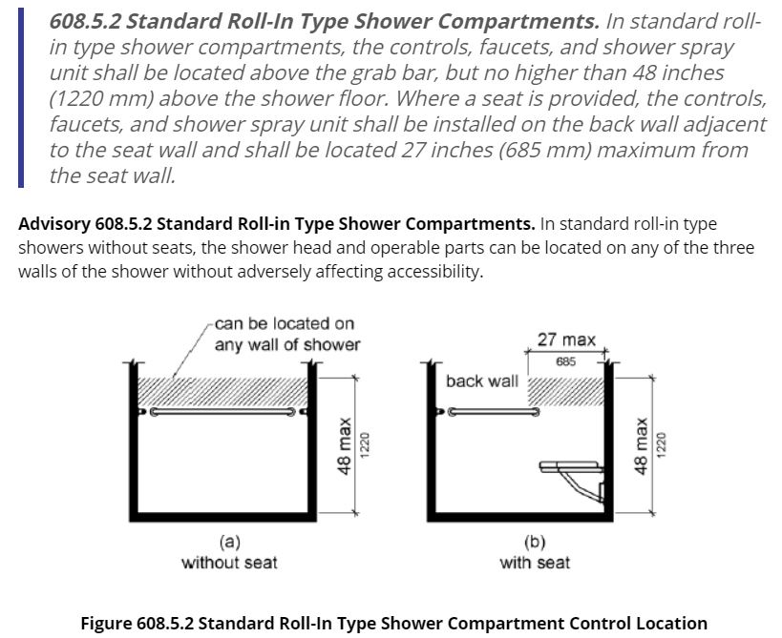

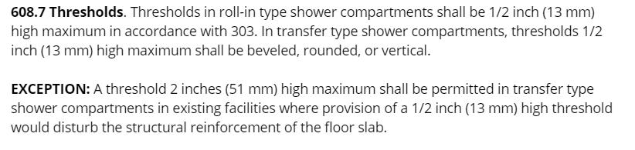

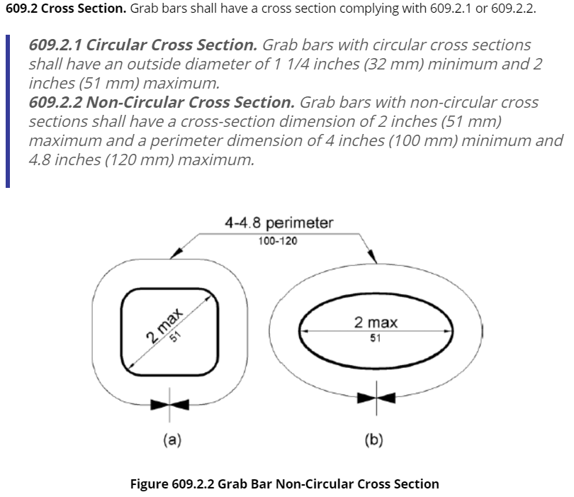

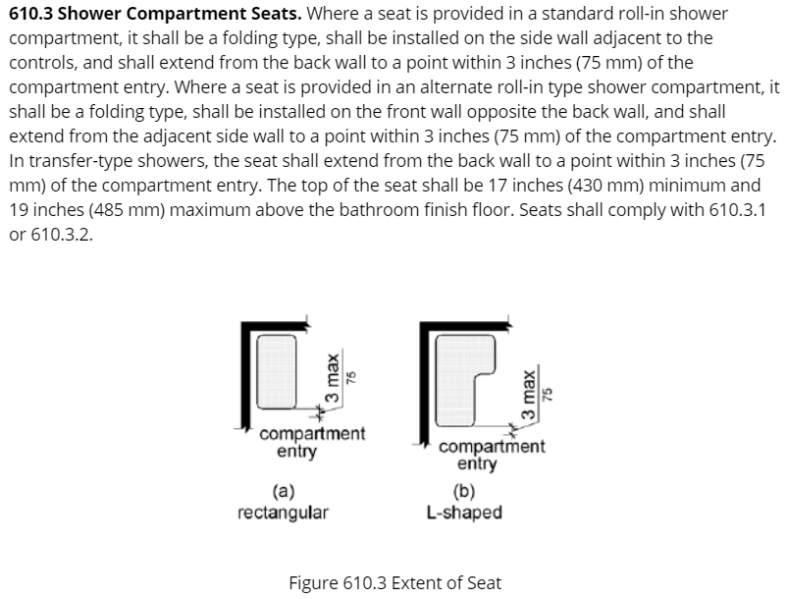

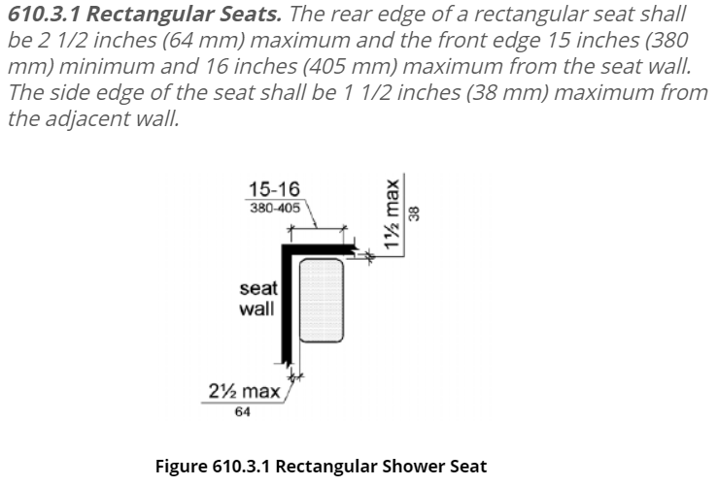

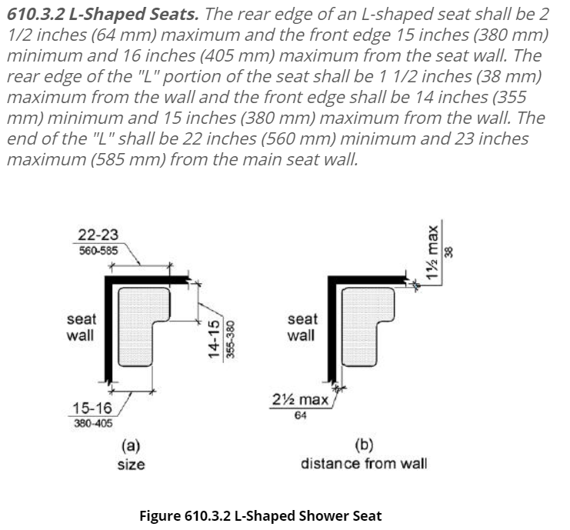

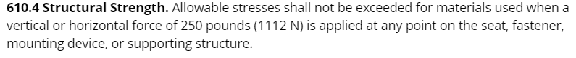

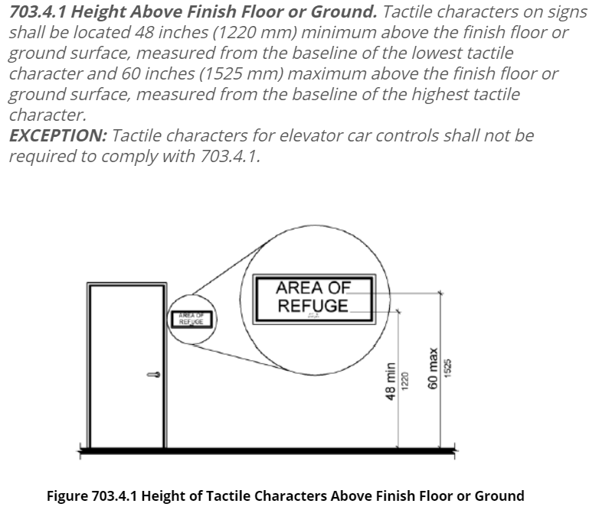

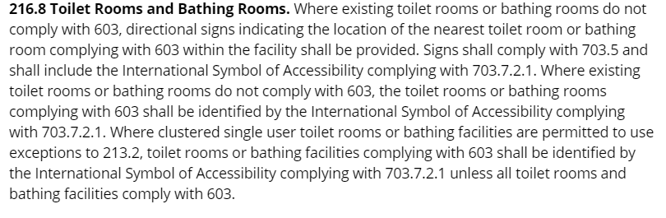

**SUBMITTAL REQUIREMENTS**

**RESIDENTIAL GROUP CARE FACILITY R-4, 6 to 10 OCCUPANTS**

SITE PLAN 1. Show the following:

● The footprint of all buildings

● Setback lines

● Lot dimensions

● Lot coverage calculations

● Square footage of all buildings

● Lot easements.

2. Size and location of **new and existing** (if applicable):

● Water meter and supply lines,

● Septic tanks and leach fields or sewer line, tap and clean-outs.

**Maricopa County approval documentation.**

● Electric service entrance section and panel, overhead or underground,

● Gas lines and gas meter

● Swimming pool and or spa

● Parking - covered and uncovered

● Driveway(s) and surface material

● Fences and gates

CODES Conforms to applicable 2018 IBC, IRC, IMC, IEEC, IFGC, IFC, IPC, 2017 NEC, ADA Standards for Accessible Design and COG amendments.

PLANS **Provide one (1) submittal set of documents in .pdf format. Submit through the City website Electronic Plan Review Submittal process. Email to: permits@glendaleaz.com**

Drawings and specifications shall be:

● Minimum 24” x 36” size

● Drawn to scale.

● Show in detail that it will conform to the provisions of our current codes and all relevant laws, ordinances, rules, and regulations

● Shall be of sufficient clarity to indicate the location, nature and extent of the work proposed. Structural engineering may be required to verify stability for gravity and lateral loads.

TRUSS DIAGRAMS All trusses need to be manufactured by an approved truss manufacturer. All truss diagrams need to be sealed by a structural engineer registered by the State of Arizona.

Exception: truss diagrams for common roof trusses that span thirty feet or less need not be submitted for review but will be required on the job site.

Composite floor joists (such as TJI’s) require a framing plan that shows all sizes of joists (engineering is not required). The framing plan needs to show all hangers and appropriate manufacturer's details.

FLOOR PLAN Label the use of all rooms of the proposed addition and adjacent rooms impacted by the addition; show floor area and ceiling height. Show location of all doors, door sizes and swing, and door landings. Provide all window sizes and types; designate the operable portion of windows and the location of tempered glass. Show compliance with light and ventilation requirements for new construction and for existing rooms affected by any addition or alteration. Cross-reference all building sections and details.

* Provide finished floor elevations, landing elevations, and ramp slopes.
* Provide clearly identifiable existing conditions and new/revised areas.

Provide all ADASAD requirements with graphic details. Including but not limited to threshold detail, shower threshold detail and solid blocking requirements for Grab Bars.

FOUNDATION PLAN Specify size, depth, reinforcing and minimum concrete strength. Cross-reference all details to appropriate section and pages.

FLOOR/ROOF FRAMING PLAN Truss identification numbers need to be referenced on the corresponding framing plan to indicate the relative location of each truss. Note the location and size of all headers, beams and/or lintel with cross-references to the corresponding connection details. Show the existing floor/roof plan with slopes. Show header or lintel sizes where weight is added. With conventional framing indicate the size, species, and grade of all framing members. Show details of over framing, gable end bracing and wall bracing.

ELEVATIONS Show elevation that applies to new addition with colors, textures, and materials. Indicate that they match the existing house. Provide attic ventilation calculations.

BUILDING CROSS SECTION A building and/or wall cross section should be used to clarify wall, foundation and roof-structure design and connections.

ELECTRIC PLAN Show an electrical floor plan. If the electrical load is to be significantly increased, provide an electrical panel schedule, and a load calculation worksheet.

MECHANICAL PLAN Habitable rooms are required to be heated by the building code. Show location of air diffusers, exhaust fans, and mechanical equipment.

PLUMBING PLAN Provide a waste isometric diagram or a plumbing floor plan. A gas isometric is also needed if gas piping is to be installed. Complete a water meter worksheet if the fixture unit load is to be significantly increased.

Provide City of Glendale Water Meter Worksheet. Indicate existing fixtures and new. Include existing water meter size.

PLAN REVIEW FEE Paid with the acceptance of the building permit application and construction drawings. An estimate of these fees should be requested on the initial contact.

PERMIT FEE Paid at time of permit issuance. An estimate of the building permit fee may be requested when the permit application is submitted.

CONTRACTOR Licensed Contractor Required. (See Memorandum)

**Djordje Pavlovic, P.E. Robert L. Juris, AIA**

Building Official Building Safety Administrator